IMI Business and Enterprise Competition:
Design the future of 2030
Students guide
Sponsored by Sytner Group

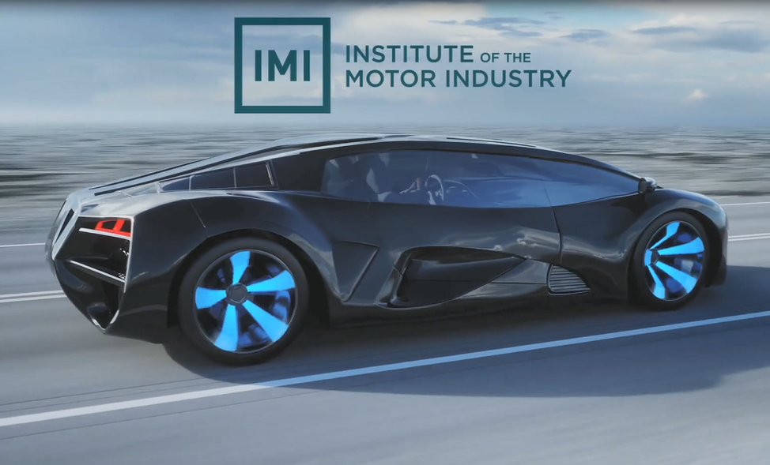

School name

Year group

Team participants | 1.  2.  3.  4.  5.  6.

Competition brief

We want you to design the vehicle of the future for 2030 with a specific target market in mind. Over the last 100 years cars have come a long way in fact most of the companies you know today would not have existed. We would like you to research and think about what vehicles will look like in in the future to support these individuals and help us shape the future of the industry.

Either individually or in teams of 4-6 work together to research, design, market and pitch your new vehicle. Keep in mind your target audience and use your unique selling point (USP) to make your car stand out for the crowd!

Finally send in a copy of your presentation or pitch to careers@theimi.org.uk or post it in, for it to be marked by the panel of industry judges. You and your team may win the top prize of an exciting automotive day out with the IMI and the competition sponsors Sytner Group!

The following pages can be used to help you plan out your project!

Within this competition you will be able to try out different career options also during the tasks.

- Task 1: RESEARCH AND DEVELOPMENT understanding your target market with planning and research
- Task 2: ENGINEER problem solving and creating your USP
- Task 3: DESIGN designing your vehicle
- Task 4: MARKETING branding your vehicle with logo and strapline
- Task 5: COMMUNIATIONS design the marketing campaign and launch event
- Task 6: SALES produce short video on vehicle – dragons’ den or elevator pitch

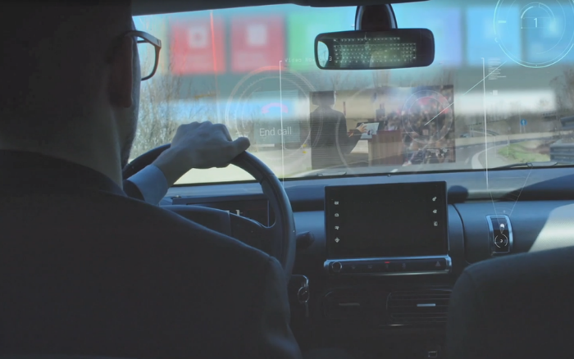

Task 1: Planning & Research

Choose a target audience and an issue to fix from the ones below. If you have another problem, you would like to help people overcome then explain their needs and requirements below.
Planning
You will need to research their preferences, lifestyles, hobbies, and finances etc.

Scenario 1
Design a new public transport of the future – how can you entice more people to use public transport more, reduce their need for a personal vehicle and become more eco-friendly?

Scenario 2
How will you support a single person living in a city with limited parking and income to be able to afford a vehicle within a restricted emissions zone?

Scenario 3
A Family of 5 who are concerned about sustainability, impact on the environment and safety for their family.

Scenario 4
An older couple who live in a retirement home, they have pets and are concerned about their future health needs.

Scenario 5
A new type of Heavy Vehicle that can transporting goods long distances and that is environmentally friendly as well as safe and a comfortable environment for the driver.

Scenario 6
Design a brand-new mode of transport for shared use for office for staff who work from home and come into the office weekly. They need a mode of transport that is available to them to get from the train station to the office which is 3 miles away.

Alternatively describe an issue of your choice to support…

Our target market is …………………………………………………………………………………………………

We chose this audience because….

Research

Research the types of vehicles already available to your chosen target audience and consider what this will look like in the future.
- What are the good bits and what could be improved?
- What technology will be available in the next 10 years?
- Why would all of these things appeal to that audience?
- What legislation on emissions will there be in 2030?

What are the main concerns and issues that your target audience need to overcome?

What is available to your target audience now?

What do you think they will need in the future?

What are the main sustainability concerns of this target market?

What are the current sustainability measures on offer?

Task 2: Problem solving

Key Features & Your Unique Selling Point (USP)

Now that you know your target audience and their requirements you need to come up with some key features and a ‘unique selling point’ that will make them choose to buy your vehicle and not one from a competitor.

Explain your unique selling point – either draw or tell us about your USP

Tell us WHY this will support and help your target audience?

Explain your sustainability or environmental impact with your new vehicle

Task 3: Design

Show us your final image of your new vehicle, remember to highlight the key features, USP and
how your vehicle will be sustainable!

Task 4: Marketing

Now you know who your audience is, what their needs are and how your vehicle will fit them it’s time to name your vehicle. What will appeal to your audience and what will showcase your USP?

Name your vehicle

Example: Volkswagen Golf

Example logos….

Design your vehicle logo

Strap line

You will need to think of a marketing strapline for promoting your vehicle keeping in mind your target audience.

Can you guess where these ones are from?

‘Because you’re worth it’

………………………………………….

‘Taste the Rainbow’

……………………………………

Design your vehicle strap line

‘Just do it’

……………………………………

Now it’s time to come up with a marketing strapline for your new car.

Ideas…

Your final strapline…

Task 5: Communication

Advertising your vehicle

You will want to promote your new vehicle to the general public and an advertising poster is a great way of doing this.

Research how and where will you advertise your new vehicle? Remember your target
market and what would appeal to them.

Examples of advertising…

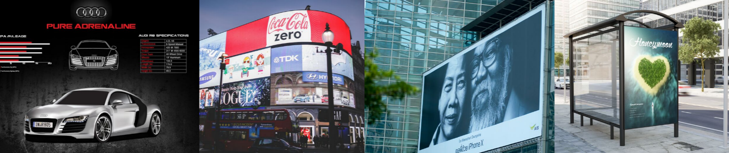

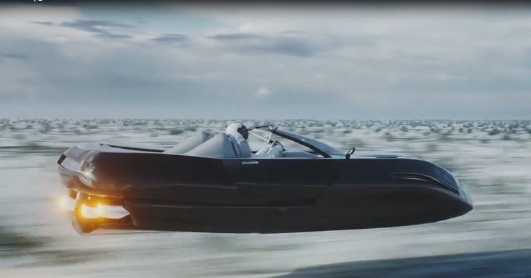

Design an advertising poster and advertising campaign

Plan your media campaign and product launch event

Devise a promotional plan by creating a media campaign to launch the vehicle onto the market:
- Which media platforms would you use to sell your product?
- Will there be a limited edition or special offer for the launch?
- Describe your launch event – when, where, what, who?

Tell us how you plan to launch the new vehicle onto the market …

How will you launch your product?
Where will your launch event be?
What will happen at your launch event?
Who is your brand ambassador?

Task 6: Sales

Your product is ready for the big launch … now to focus on ‘selling’ your vehicle!
Are you ready?

Now it’s time to get all your ideas and plans together to create a final presentation for your new vehicle.

You can complete the competition using any of the following formats:

- A PowerPoint presentation
- A written presentation on A4 paper
- A filmed 5 minute ‘elevator pitch’ of your ideas

Checklist

Before you submit your designs ensure you include evidence of the following:

Competition Checklist | Done
Target audience
Research
Name your vehicle
Branding
Design a logo
Key features & USP
Design your vehicle
Marketing Strapline
Advertising poster
Media campaign
Launch event
Prepare your big pitch

Please send your entries by email to careers@theimi.org.uk or post to The Careers Team, Institute of the Motor Industry, Fanshaws, Brickendon, Hertford, Hertfordshire SG13 8PQ by Friday 17th June 2022.

Good luck!

Careers & Student Team - Institute of the Motor Industry

Special thank you to our competition sponsor:

