Automotive Work Experience Toolkit
Organisers guide

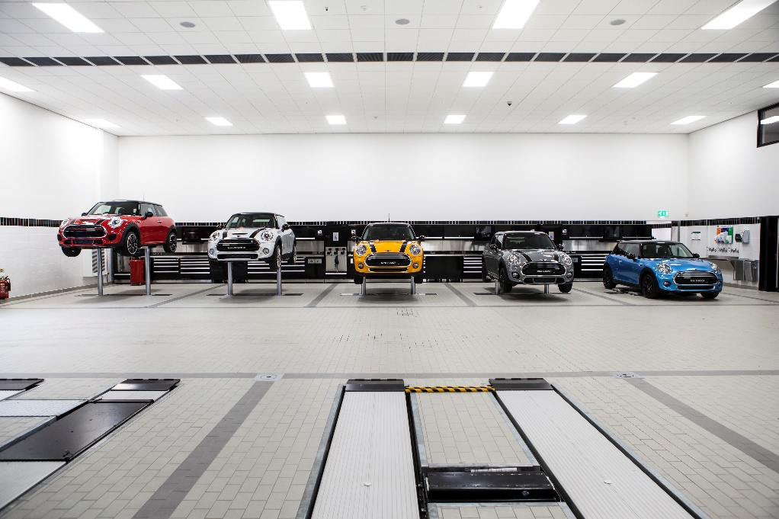

Content

About Sytner Careers | Elements of a Good  Work Experience Placement
Overview | Contact Details
Benefits of Work Experience | Health and Safety Checklist
Information for Organisers | Work Experience Checklist
Work Experience Guidance | Work Experience Placement Diary
About The Automotive Industry | Frequently Asked Questions

The IMI
The Institute of the Motor Industry is the professional body for individuals working in the motor industry and the authoritative voice of the retail automotive sector. The IMI’s aim is to ensure the automotive retail sector has a skilled, competent and professional workforce that is fully equipped to keep pace with the demands of new technology and changing markets. A key part of business for manufacturers and dealers is to encourage the best and brightest people to join their business in a variety of roles.

Contact Us
If you have any questions of feedback please contact us on careers@theimi.org.uk

Work Experience Toolkit Overview
The Work Experience Toolkit provides enjoyment for work experience placements with the achievement of the maximum learning benefit from the work experience placement. Students will have an insight into the retail motor industry and an ability to make informed decisions about future career options.
You will also receive guidance notes, forms, workbooks and suggestions to ensure that employers and schools have the means to deliver a successful work experience placement in the retail motor industry.
Whether you’re an organiser of work experience, an employer in the sector or a student considering a work experience placement in the retail motor industry, these toolkits contain all you need to ensure a well-planned, meaningful period of work experience or a successful job application.

These guides include:
- The benefits of work experience
- Information for work experience organisers
- Information for students
- Information for employers
- Useful templates
- Frequently asked questions

The benefits of Work Experience

By offering work experience placements to students, employers can:
- help promote a positive image of the industry
- help promote a positive image of their company locally
- identify potential future employees
- help students develop their knowledge of the industry, so they can make informed choices about what to do in the future
- help improve the work readiness of young people preparing to enter the workforce
- recruit more informed school leavers, who are more likely to stay in the sector because they have a better understanding of the retail motor industry
- make the company more attractive to potential recruits
- help promote the relevance of vocational qualifications within the sector
- meet the company’s social/corporate responsibility policy

And help staff to develop their:
- project management, organisational and planning skills as they operate work experience placements
- coaching skills as they work with students
- communication skills as they prepare assignments or projects related to their department or job role for the student to complete during the course of the placement
- ability to reflect and make amendments to programmes as they review the quality of what happened during the work experience placement

This toolkit provides guidance and practical information on how to deliver a quality and worthwhile work experience placement within the retail motor industry. It has been provided to help students achieve the maximum learning benefit and gain an insight into the retail motor industry and the career options on offer.

Information for Work Experience Organisers

When organised and delivered effectively, work experience can form an important part of a young person’s education and personal development. Many schools and colleges will have their own ways of organising work experience placements, but this toolkit is provided to help promote best practice in work experience placements when delivered in the retail motor industry.

This toolkit can be used to help make sure that students:
- enjoy their work experience placement
- achieve the maximum learning benefit from the work experience placement
- gain an insight into the retail motor industry
- make informed decisions about their future career options.

This toolkit provides guidance and practical information on how to deliver a quality and worthwhile work experience placement within the retail motor industry. It has been provided to help organisers ensure that students achieve the maximum learning benefit and gain an insight into the retail motor industry and the career options on offer.

Guidance
Work experience forms an important part of a young person’s education and personal development. Many schools and colleges will have their own work experience packages to assist with the organisation of work experience, however this toolkit was produced to help promote best practice in organising work experience placements within the Retail Motor Industry.

Within the toolkit you will find guidance information, forms and documents designed to help all parties ensure that the student enjoys a rewarding experience, allowing them to achieve the maximum learning benefit as well as gaining an insight into the retail motor industry as a career option.

Increasingly the motor industry strives to recruit high-calibre people able to meet the demands of a fast moving, technologically advancing, customer driven industry. These individuals fulfil a variety of job roles not only in the technical field but also in other critical areas where a wide range of skills are required. Skills such as project management, research, finance, insurance, law, human resource management and marketing are all at the core of today’s retail motor industry.

All of the above roles demand a competent, flexible workforce able to adapt to the demands of an industry operating at the leading edge of technology and meeting increasing levels of customer expectation. This work experience toolkit has been produced to assist you in organising a placement in the retail motor industry. There are a diverse number of opportunities for young people to experience working in the industry, either with a small business or a large franchised dealer, in technical and non-technical roles and this toolkit aims to support you in delivering a successful placement.

Contained within the work experience organisers’ section of the toolkit are guidance notes, forms and documents for use in preparing and administering the placement:

- The Retail Motor Industry
- Elements of a Good Work Experience Placement
- Organising a Good Work Experience Placement
- Organising Work Experience Placements Checklist
- Health & Safety Information
- Contact Sheet
- Record of Assessment

About the automotive industry
The automotive industry influences everyone, from delivering goods on time to commuters travelling to work and emergency services being able to respond to a crisis, the motor industry helps keep the country moving.

The retail motor industry
The retail motor industry employs around 570,000 people in just under 70,000 companies across the UK. These companies range in size from firms with fewer than 5 employees to large companies with over 500. This variety of businesses sells, maintains and repairs the 38 million vehicles on our roads. The industry can be split into the following sub-sectors:
- Vehicle Fitting (including Fast-Fit and Tyres)
- Vehicle Maintenance and Repair
- Vehicle Body and Paint Operations
- Roadside Assistance and Recovery
- Vehicle Sales
- Vehicle Parts Operations
- Vehicle Rental and Leasing

A great deal of knowledge and competence is required in all of the sub-sectors in order to keep up with technological advances. The development of software packages to manage and control almost every system on a modern vehicle, whether a family car, motorcycle of a 40 tonne articulated truck, require a level of understanding of IT and electronics as well as the more traditional mechanical knowledge.

Commonly, recruitment of young people is through an Apprenticeship lasting three years however some positions such as vehicle sales and rental and leasing require individuals to show a degree of maturity to win the confidence of clients, and, due to insurance reasons, many companies have a minimum age requirement of 21 for these roles.
As well as technicians, fitters and sales staff each sub-sector also offers many opportunities in a variety of non-technical roles including:
- Administration
- Management
- Marketing & Promotion
- Finance
- Insurance
- Human Resources

For more information on all roles and entry routes please see www.autocity.org.uk

The elements of a good work experience placement

- Agree the aims for the work experience placements
- Brief students about the work experience placement
- Use the work experience placement to provide students with a quality learning experience
- Organise debriefing sessions to help students confirm what they have learned.
- Plan Work Experience Placements
- Support students during their work experience placements
- Review and evaluate how work experience placements are organised and managed

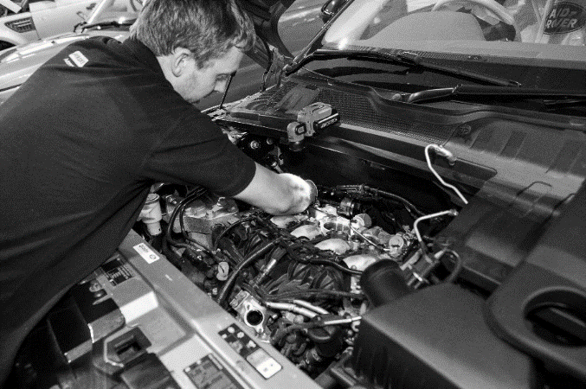

- Agree the aims of the placement
Agree what the work experience placement aims to achieve and identify the expected outcomes e.g. do you want the student to experience different sectors within the retail automotive industry? Or do you want the student to understand how people can develop a career in one area of the industry such as maintenance and repair, where over time employees develop their skills and become Master Technicians or managers?

Work experience placements help students to:
- Prepare to join the world of work
- Understand how different the world of work is from the world of school
- Understand what is expected of employees
- Understand the responsibilities of employment and what is expected of employees (See the IMI’s Employability Skills Toolkit for more on this)
- Develop their social skills
- Make informed choices about what career routes are available
- Understand what qualifications are required to help them manage and realise their career aspirations
- Put into practice what they have learned in the classroom

Work experience placements should be as realistic as possible, but must be organised within some framework where students do not:
- Work for more than 8 hours a day
- Work for more than 37 hours in a week
- Start work before 0700hrs in the morning
- Finish work after 2000hrs in the evening

By requiring students to work a normal day, which would typically mean working 9am – 5pm (with an hour for lunch plus refreshment breaks) they will grow to understand the difference between the world of school and the world of work. Students should always be encouraged to work longer than a normal school day.

When identifying and planning activities that the students can complete, do not be afraid to give employers permission to manage the activity: ask them what the students could do as they will probably have ideas of their own and want to get actively involved.

- Brief students about the work experience placement
Prior to students actually going out to the employer it is advisable to run briefing sessions for them. These sessions should be designed to bring out into the open any fears or worries they might have about going to an employer and brief them on what is expected of them and what they can expect. During these sessions the opportunity should be taken to:
- Describe what the world of work is like and how it is different from school
- Talk about what sort of clothing would be acceptable in the workplace
- Discuss if they will be expected to wear and protective clothing (provided by the employer) or if they will need to take any other items with them
- What sort of behaviour is expected of them
- Do they need to take lunch / is there a canteen
- What they must do if they are not able to turn up for work and who they should contact
- Agree any learning objectives
- Explain the purpose of the diary / logbook and how to complete it
- Explain if and when they can expect to be contacted or visited by a teacher
- Identify and common problems that may arise during a placement and explain what a student should do if they have a problem
- Answer any questions and reassure students

As part of this induction type programme it might be useful for the student to visit the employer before the start of the placement (if possible). An informal visit might help make them feel more confident about where they are going / who they are meeting etc.

For more information and suggested activities on the above bullet point please see the IMI’s Employability Skills Toolkit.

- Use the work experience placement to provide students with a quality learning experience

When students are out on work experience placements they:
- should take part in an induction exercise where they are introduced to the employer and become familiar with the layout of the business and what will be expected of them. The induction should explain health and safety requirements and if applicable why safety clothing and / or equipment must be worn or used

- should develop an understanding of the business. Employers should help the student understand how the business works and describe what pressures there are on the business. Through these activities the student could for example develop an understanding of:
  - the career opportunities available in the retail motor industry
  - the training opportunities within the business
  - the impact of legislation on business
  - what customers expect from the business
  - the relationships between workers, managers and customers

- must do real work in real jobs. For the young person this will be a key element to the success of the placement. Students must actually work with or around vehicles because this is most likely why they will have selected this type of work experience

- should be required to complete assignments designed to help them get the most out of the experience. These assignments could be designed to help the student develop an overview of the business, understand how employees communicate in the workplace, or develop their skills of working with others and understanding how health and safety issues are managed

- will need to be monitored to make sure that the work experience placement is worthwhile and appropriate. These monitoring visits / calls should be used to review what has happened on the work experience placement. The student should be asked to identify what they have learned and time will be needed to review the student’s placement. In order to make this a worthwhile exercise the student will be required to keep some kind of review document (such as the suggested diary) and answer questions on what they have done / learned

- should have a debriefing meeting with the employer at the end of the placement. This will provide the employer with the opportunity to identify what went well and give feedback on any areas for improvement (constructively), while the student can reflect on the experience and comment on any feedback received

- Organise debriefing sessions to help students confirm what they have learned
After the work experience placement is over organise a debriefing session where the student can review what they have experienced. How a debriefing session is organised is up to the school work experience organiser but to give it credibility and a sense of importance, it must be structured and well-organised and be made up of several elements. For example, a well-structured debriefing exercise could include:
- one to one sessions
- group discussions
- presentations
- an event to celebrate success

One to one sessions should be used to help the student confirm what was learned. Teachers will need time to sit down and discuss with the student what happened. To help this process, documents should be provided to record what was discussed and the meeting should take place in comfortable surroundings where interruptions can be avoided. The session can be used to allow the student to present any assignments / project work that was carried out during the work experience placement and agree how it can be used for class work.

Group discussions could be used to encourage a group of students to talk about what happened and what they experienced. You may ask each student to make a short presentation about their work experience placement to other members of the group. They will have to be given guidance on what they should include.

They may want to describe the company, present the results of the project they completed during placements, or simply describe what they did and explain what they have learned. They could be encouraged to prepare a PowerPoint presentation and a set of handouts which may be used towards core skills certification.

None of the activities described are mutually exclusive. You could use one or more of them to help students consolidate what they learned. Opportunities to get the students to organise the activities themselves should not be missed, because these will provide them with opportunities to develop their team building and planning skills.

- Plan work experience placement

You will need to make sure that employers are well briefed about the placement. They will need to know:
- about the calibre of the student attending
- what the student has been learning and what skills they have been developing
- what they are expected to do for the student during the placement

Employers should be encouraged to identify what they can do to help make the work experience placement a worthwhile experience. For example, is the employer able to move the student around different parts of the business where they might work in the showroom, back office or in a service and maintenance or accident repair workshop?
The following areas need to be addressed prior to the placement commencing:
- Health and safety checks of the working environment have been conducted and risks have been identified and minimised.
- Where necessary Disclosure Scotland checks have been carried out on employees who will have sustained contact with students during work experience placements (for more guidance on requirements visit www.disclosurescotland.co.uk)
- Employers have checked with their insurance companies that they have sufficient insurance cover in respect to work experience students.
- Assignments / workbooks for students to complete during the work experience placement may need to be developed. These could include investigations into how the company is organised and an analysis of how many other businesses including suppliers the company works with and depends on. An example workbook is available with this toolkit.
- So that employers understand more about the student, if possible it is a good idea to set up interviews, where the student attends an interview in order to secure a work experience placement with the employer.
- You will need to make sure that parents or carers understand what will happen during work experience placements. They will need to be assured that health and safety issues have been covered and need to have an idea about what the students will be doing. They will also have to give their consent, so all the necessary paperwork and procedures will need to be in place.
- In order that parents and carers have a good understanding about work experience and feel assured that it is well organised and managed, an evening could be organised to brief parents and answer their questions. The evening might include a presentation from an employer who explained why the company has agreed to get involved. The aim of these sorts of activities is to create robust partnerships between the schools, employers and parents / carers.

- Training and briefing sessions for staff on how work experience placements are delivered should be organised so they know exactly what they are required to do. This will give members of the team the opportunity to ask questions on issues that concern them.
- Students will need essential details about the work experience placement. For example, they will need to know:
- who to report to
- where to go
- the hours of work
- arrangements for lunch & tea breaks
- dress code
- how to get there
- who to contact if they cannot get to work
- school contact details
- emergency contact details for if they have a problem
Some of the information that students need can be included in the forms available within this toolkit. Induction with the placement employer should also cover many of these topics.
- Employers will need to know who to contact if something happens during a work experience placement. You will need to put in place a system for something as simple as a student not turning up for their placement. The employer should know exactly who to tell and the parents or carers of students should know who to contact if they are not able to attend their placement.

- Support students during their work experience placement
Now that all the plans for the work experience placement have been carried out or put into place, students should be ready to take part in their placements. During this stage, when students are out on work experience, they will need to be supported and their work monitored. Therefore, systems will need to be put in place to ensure students receive this support.
- Hold briefing sessions for students before they actually go out on work experience placements. These sessions should be designed to bring out into the open any fears they might have about going to an employer and brief them on what is expected of them. The sessions could be used for example to:
- brief the student on what they should do
- agree learning objectives
- agree how the placement will be monitored (visit / telephone call)
- hand out diary, workbooks, assignment or project material
- give out contact details

- Staff responsible for monitoring the placement should identify what sort of tasks the students are doing during the placement in order to make sure they are within the student’s ability or to encourage the employer to give the student more demanding tasks.

- Students should be encouraged to review their own progress and assess what they are learning from the experience. Where possible, the employer should be encouraged to take part in this process.

- Review and evaluate how work experience placements are organised and managed
It is often recommended that reviews and evaluations of systems and processes be conducted, but sadly this is not always done properly due to lack of time or resources. In this case the review and evaluations should be carried out to identify how the system and processes used to organise and manage work experience placements could be improved. It is up to the school how this is done but the following guidance may be useful:
- Form a small working party charged with managing the review and evaluation and decide who should be involved. This should ideally include students and employers who will be able to advice on issues arising from the work placement. The system of review and evaluations needs to be employer friendly; this means it must not be over bureaucratic or time consuming.

- Decide on the purpose for the review and agree some objectives.

- Decide how the review will be carried out, for example, will people be asked to:
- complete questionnaires (i.e. through Survey Monkey)
- take part in telephone interviews
- take part in face to face interviews
- take part in group discussion

- Decide what areas will be included in the review. The following questions are supplied to help you identify what may be included.
- How effectively were employers briefed prior to the placements?
- Did the employers believe that they provided students with the best possible experience?
- How well were health and safety checks conducted?
- How effective were the workbooks, assignments or projects developed for the students?
- How useful was the dairy / logbook?
- How effective were the systems used to brief parents and carers?
- How effective were the reporting systems used to provide support?
- How effective were the lines of communication between all participants?

- The aim of the review should be to assess if the systems, processes and paperwork used in any of the above areas could be improved.

- Once the areas for improvement have been identifies an action plan will need to be developed, where particular tasks, target dates and deadlines are agreed.

Contact details

A copy of this contact sheet should be retained on file by the work experience organiser and copies given to both the student and the placement provider.

Student
Name |  | Year / Class
Emergency contact
Relationship |  | Mobile no.
Home no |  | Work no

School / College
Work experience organiser
School / College |  | Tel no
Address

Placement provider
Contact |  | Position
Company |  | Tel no
Address

Comments
Note any special requirements or conditions for this student or placement

Health and safety checklist

A copy of this checklist should be retained on file by the work experience organiser.

Placement
Address
Tel no

Insurance
Employers Liability Insurance Certificate
(covering students on work experience)
Public Liability Insurance Certificate
Registration
Placement registered with appropriate authority (HSE or Local Authority)
Health & Safety Policy
Where there are more than 5 employees the placement must have a written Health & Safety Policy.
Health & Safety Law Poster
Health & Safety Law – What you should know poster should be displayed or a leaflet available for the student.
First Aid arrangements | First Aid Box  First Aiders
Fire Precautions | Fire exits / Assembly Points  Fire extinguishers  Appropriate Signs  Alarm
Accident Reporting | Accident Book

Placement Contact: ______________________________________ Signed: ___________________
Work Experience Organiser: _______________________________ Signed: ___________________
Date: __________________________

Work Experience Checklist
Use the following checklist to help you ensure everything is in place for a good workplace experience.

1 | The role of employers | Yes ✓
 | Employers are well briefed about the programme
 | All legal requirements have been met
 | Employers have identified activities for the students
 | Employers have provided feedback on students’ progress
2 | Good Practice | Yes ✓
 | The experiences are linked to what the students are learning
 | Assignments for students have been identified & designed
 | A diary / logbook for students to complete is available
 | Parents and carers have been briefed
 | Students have been given essential information about their placement
 | Everybody knows what to do if something goes wrong
 | One person has been identified as main contact should something go wrong
3 | Support Systems | Yes
 | A session to brief students about work experience has been arranged
 | Support systems have been identified
 | Student progress is monitored and reviewed
 | Experiences and outcomes are recorded
 | Employers take part in student reviews
4 | Review and evaluation | Yes ✓
 | The systems for managing and organising work experience placements are reviewed & evaluated
 | Materials used to review how work experience placements are managed & organised are in place
 | People have been identified to take part in the review
 | Methods of carrying out the review have been agreed
 | What areas will be included in the review have been agreed
 | An action plan to improve how work experience placements are managed & organised

Work experience placement Diary – example
Use this form to record the daily tasks and activities you carry out during your work experience placement.
Work experience programme for | John Smith | At | ABC Motors

Day / Date | Morning | Where | Afternoon | Where
Monday 14th June | Induction with Jim Brown, Administration Manager. Was shown around dealership and met the people I will work with during my placement. Issued with overalls and boots. Agreed with Mr Brown my programme for the week. | Office | Went to service reception and helped the receptionist record details on the computer and passed job cards on to the workshop. Did the task to find out the repair status of the sales car damaged in a crash. | Reception
Tuesday 15th June | Worked with technician servicing a Volvo. Helped check systems on a new car before it went out for delivery to the customer. Chris showed me how to check tyres for wear to make sure they are safe & legal. | Service Workshop | Helps Chris to find a fault with a car that had no heater fan. Used special equipment to test wiring and found a faulty switch, fitted a new one. Helped John do an MOT on a Fiesta. | Service Workshop
Wednesday 16th June | Helped Bob in the parts department put spare parts into correct bins and used computer to find parts. Did exercise set by Mr Brown to get parts ready for delivery van. | Parts Department | Built display and put up posters for new oil promotion. Served mechanics at workshop counter. | Parts Department
Thursday 17th June | Went to training show on new car with sales department. Unpacked new car sales displays and posters. | Training Room | Set up new promotion in showroom. Put up posters and displays in windows. Helped move cars in from transporter and clean them. | Showroom
Friday 18th June | Did a challenge in sales department where I had to find best car for the Smith family. | Showroom & Office | Got to see what the office does with Steve and then Mr Brown had a chat about my week. Filled in my forms. | Office

Work experience placement diary

Use this form to record the daily tasks and activities you carry out during your work experience placement.

Work experience programme for |  | At

Day / Date | Morning | Where | Afternoon | Where

Frequently asked questions

What will I do on my work experience?
You will gain an understanding of the world of work and the skills, abilities and attitudes you will require to be successful in the workplace and how these relate to your school work. You will experience what it is like to be employed in the retail motor industry and, depending on the size and type of company, the range of jobs available. You may work with people in technical roles repairing vehicles in the workshops, assisting service advisors and receptionists dealing with customers, providing admin back up to ensure the garage runs smoothly, or supporting the sales and parts departments. A work experience placement can provide an insight into what a job in the motor industry is like and help you to make informed decisions about our future.

Will I attend at the same times as when I am at school?
The hours you attend work experience will be agreed with the employer and your placement organiser. However, for you to gain a real insight into the world of work and experience the daily routine, you should expect your working day to be the same as the people you will be working beside.
What if I find this isn’t the job I want to do?
Then you have learned something from the experience and will be able to rethink your career plans. Even if you find that a job in the motor industry is not what you expected, you will have gained a valuable understanding of what the world of work is like. Things like team work, communication, good timekeeping and appearance are important in any job and every work experience placement provides the opportunity to see why these matter, helping you prepare for the career you eventually decide is right for you.
Will potential employers recognise my work experience?
Yes. Employers realise the benefit of work experience and are more likely to recruit someone who has attended a work experience placement. You may be given a certificate recognising a successful placement and you should ensure that details of your placement are added to your CV. Many work experience placements can lead to an offer of a job.

Where can I find information on degree courses and university work placements?
The IMI has launched a new Graduate and Undergraduate section on our Jobs Platform, where applicants can now search for degree-level opportunities, internships and gap-year placements alongside apprenticeship vacancies: www.imijobs.org.uk

How can I prepare my students for work experience in the motor industry?
Included in the toolkit is a section for your students with guidance and information to ensure they are well prepared for their work experience in our industry.

I already have information for organising my placements. How will this toolkit help me?
The Automotive Work Experience Toolkit has been designed specifically for work experience within the automotive sector, providing guidance and information on how to ensure your students gain the best experience in our industry. The toolkit includes all the necessary forms and documents to help you set up and manage an automotive work experience placement. It also provides your students and the employers you work with tasks and projects which will help them structure their time in the workplace highlighting the range of skills and abilities needed by the retail motor industry.
Employers in my area are reluctant to get involved. What can I do?
Many smaller employers in our sector find it difficult to organise and manage the work experience placement and therefore find it easier not to become involved. By providing them with guidance on how to go about it, with a structured programme they can work to and pre-prepared documentation you can make the process as straightforward as possible. Hopefully this will ensure that a hassle free, enjoyable and high quality work experience placement is provided. Once on board employers can be encouraged to participate in other activities such as school visits/talks, teacher placements, mock interviews etc - strengthening relationships with their local schools and the local community.

Can I download/print the forms?
All the documents are in pdf format and available for you to download and print.

For more information please visit www.theimi.org.uk/autocity

Contact us with any questions, queries or feedback on careers@theimi,org.uk

The IMI Careers Team

